Insert Tab

- In the insert tab you can put shapes, objects, tables, charts and Word Art.
- With internet you can add pictures as well from the internet.
- New tabs open when you insert something and click on it. Ex.
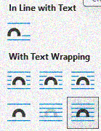
An object you insert can be in “line with text”, which means it functions like a text line and can only be put like a normal text. If you “Text wrapping” it will make the object be anywhere according to the wrap you choose. Try them out to see all the wraps.
- When you click an object, a new tab appears on the top called Shape format. Pictures have picture format when inserted.

